Social Media Content Strategy for Live Broadcast:
Media Literacy for the 21st Century: We Are All Journalist Now
Broadcast: March 2, 2018 Content Calendar: November 1 2017 - March 2, 2018

Episode Summary
Click, Like, Share. . . Record, Write, Post.

What is the future and fate of journalism – and our democracy – now that technology gives every citizen the chance to be his or her own broadcast tower?

In this chaotic and saturated 21st century media landscape, every citizen needs the skills of a well-trained journalist in order to be both a better consumer of media and a responsible creator of media.

This special one-hour live webcast will include regional and national experts who provide crucial information to help young people and adults develop critical thinking skills; learn how to authenticate information; improve accuracy and clarity in writing; and distinguish the different types of information they encounter on the internet and in the news media.

The program’s panel of experts and educators also will discuss and debate challenges facing the media industry in the current politically charged and partisan atmosphere in our country; and they will debate ways to counter “journalism of affirmation,” a political media strategy that attracts viewers by cherry-picking information and propaganda that affirms the biases and pre-conceived notions of its audiences.

Viewers will be able to submit questions for the panel through social media and have those questions answered live during the program. WQED Multimedia also will provide customizable marketing/promotion materials and Discussion Guides for groups to hold off-site Watch Parties and town hall meetings.

Content Theme Objectives:
- Recruit educators/ school districts to broadcast the web episode in their school/classroom
  - Details of the events
  - Crosswalk to 21st century skills
  - An ecard and social media post image for Twitter, Instagram and Facebook.
- Sample Content to solicit questions
  - We Are Journalist Now
  - Express Yourself
  - Record, Write, Post
- Create a toolkit resources for broadcasters to share with educators
Hashtags: #newseum | #ExpressYourself | #FirstAmendment | #iQsmartparent | #wqed | #digitalinnovators | #JournalistNow | #remakelearning | #makerEd | #mediamaker | #iste | #istechat | #namle | #medialiteracy | #medialit

Recruit educators/ school districts to broadcast the web episode in their school/classroom
- The target market for recruiting the school/classroom to participate in the broadcast

Educators | School District Professionals | Out of School Time Orgs.
English Teachers,Journalism Educator | Media Specialist,  STEM Specialist, | Yearbook club, School Newspaper
Technology Instructors | Principals | Creatives
 | School District Communication Department | Student-run school media club
Media Educators | State Dept of Edu - Innovation | Media Labs
Social Studies Teachers, History Teachers, | Director of Innovation  Innovation Specialist | Communications at local & regional University/Colleges
Visual Arts Educator | EdTech Professionals | Writing Initiatives

- Create a registration form to collect information about participating schools & organizations. The form should include: Name, Organization, Email, Day of Contact, Logo Upload
  - Send an e-blast to target market with a registration form.
  - Create a post with link registration form to social media as pinned or sponsored.
  - Add form to website

- Share the ecard across social media platforms: Snapchat, Twitter, Instagram & Facebook. Don’t forget to tag your local school district, outstanding educator, Office EdTech, State Dept. of Edu, and local professional organizations affiliates

  - Create content to attract educators/ school districts to participate in the webcast
  - Create a Geofilters on SnapChat
  - Create a Frame on Facebook
  - Create an Instagram Story
  - Create a meme
  - Create a PSA (video,animation or audio)
  - Create a GIF (we recommend GIPHY)
    - Announce webcast broadcasting opportunity and how to register school district or classrooms
    - Use logos of school that signed on to attract more in the area

Sample post to attract school districts, schools, and classroom with details about the events

- Twitter:
- Join [APT Affiliate] & #iQsmartparent for special, live webcast "MediaLit for the 21st: We Are All Journalists Now" on 3/2/18, 11:30am (EST)
- Host a WATCH PARTY for "MediaLit for the 21st: We Are All Journalists Now" on 3/2/18, at 11:30 am (EST), live national webcast. - IMAGE ATTACHMENT with details to register
- PLAN a POP UP NEWSROOM for "MediaLit for the 21st: We Are All Journalists Now" on 3/2/18, at 11:30 am (EST), live national webcast.
- #MEDIAMAKERS | Grab a #greenscreen and join "MediaLit for the 21st Century: We Are All Journalists Now" on Mar. 2, 2018, at 11:30 am (EST)

  - Facebook
  - Join [APT Affiliate] & #iQsmartparent for special, live webcast "Media Literacy for the 21st Century: We Are All Journalists Now" on March 2, 2018, at 11:30 am (EST)
The program’s panel of experts and educators also will discuss and debate challenges facing the media industry in the current politically charged and partisan atmosphere in our country; and they will debate ways to counter “journalism of affirmation,” a political media strategy that attracts viewers by cherry-picking information and propaganda that affirms the biases and pre-conceived notions of its audiences.

Register your classroom or school to join the live webcast. Registered schools and classrooms will be highlighted on our website and social media outlets.
Registration is not required.
URL LINK

  - Host a WATCH PARTY for "Media Literacy for the 21st Century: We Are All Journalists Now" on March 2, 2018, at 11:30 am (EST), live national webcast.

This special one-hour live webcast will include regional and national experts who provide crucial information to help young people and adults develop critical thinking skills; learn how to authenticate information; improve accuracy and clarity in writing; and distinguish the different types of information they encounter on the internet and in the news media.

Register your classroom or school to join the live webcast. Registered schools and classrooms will be highlighted on our website and social media outlets.
Registration is not required.
IMAGE ATTACHMENT with details to register

  - PLAN a POP UP NEWSROOM for "Media Literacy for the 21st Century: We Are All Journalists Now" on March 2, 2018, at 11:30 am (EST), live national webcast.

What is the future and fate of journalism – and our democracy – now that technology gives every citizen the chance to be his or her own broadcast tower?

In this chaotic and saturated 21st century media landscape, every citizen needs the skills of a well-trained journalist in order to be both a better consumer of media and a responsible creator of media.

Register your classroom or school to join the live webcast. Receive an educator’s toolkit with ideas for project-based learning. Registration is not required.
URL LINK

  - #MEDIAMAKERS | Grab a #greenscreen and join "Media Literacy for the 21st Century: We Are All Journalists Now" on March 2, 2018, at 11:30 am (EST)

In this chaotic and saturated 21st century media landscape, every citizen needs the skills of a well-trained journalist in order to be both a better consumer of media and a responsible creator of media.

Register your classroom or school to join the live webcast. Receive an educator’s toolkit with ideas for project-based learning. Registration is not required.
URL LINK

  - Instagram
  - Add registration link to profile
  - Create an Instagram Story
  - Upload GIF video with caption: Join [APT Affiliate] & #iQsmartparent for special, live webcast "MediaLit for the 21st: We Are All Journalists Now" on 3/2/18, 11:30am (EST)
  - Create a PSA using a video,animation or audio
  - Create a Boomerang to attract people to do a Pop Up Newsroom.
  - Make a video using the printed props template to attract people to Watch Party

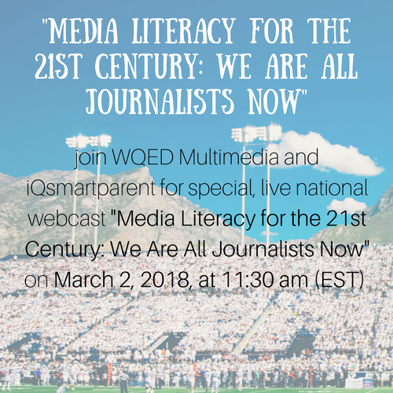
  - Snapchat

  - Create a Public Service Announcement about the importance of real news

  - Create a challenge for the school/classroom to compete using social media
  - Win a Instagram Frame or Snapchat Frame
  - Field trip to the studio
  - In classroom web interview
  - Conduct an interview with a person that works a

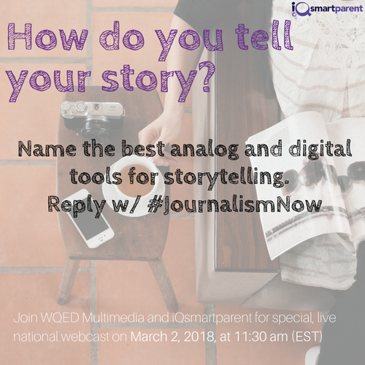
Sample Content to solicit questions
- We Are Journalist Now
  - Use a image from a local sport and crowd event with people using their device to share their experience.
  - Ask, who is telling your community’s story?
- Express Yourself
  - Create a Behind-the-Scene video with caption: We are all journalist now! #AskAMakerEducator what tools are they using to record, write and post information. #mediamaker #media #makered
  - Ask, how do you tell your story?
  - Have a school.classroom create a public service announcement about being a responsible media creator.

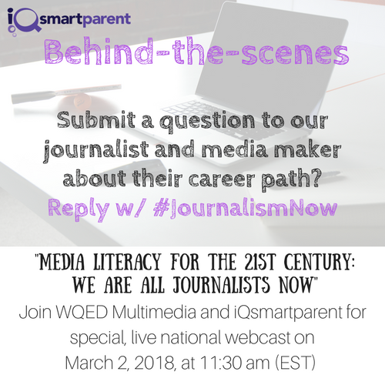
- Record, Write, Post Challenge
  - Have schools/classrooms to host a challenge to record,write and post questions for to be asked during.
  - Have a school/classrooms write, record and post a public service announcement about real news.

Featured Guest Teaser to inform professional development organizations and the community at large the webcast is help
- Share out the featured guest bio
- Share out the organization they work at
- Encourage them to ask the expert.

Harness the power of professional organizations and alumni affiliation.
- Do your station belongs to one of these professional organizations?
- Reach out to them to spread the word.
- Tag the local affiliate of a professional organization
- Reach out to your alma mater to spread the word with other alum

Professional Journalism Organizations | Media Literacy Organizations
American Press Institute | Online News Association (ONA)
American Society of Newspaper Editors | College Media Advisers Online
Newseum Institute | Associated of Press Media Editors
Education Writers Association | MakerEd #AskAMakerEducator
Newspaper Association of America | Connected Learning Research Network
Journalism Education Association | Media Literacy Now
National Newspaper Association | National Association of Media Literacy Educators
National Press Club | New America https://www.newamerica.org/
National Association of Broadcasters | Common Sense Media
Radio-Television News Directors Association | LRNG Network
The Association of Magazine Media | Digital Media + Learning Central

The Newspaper Guild

The Pulitzer Prizes

Investigative Reporters and Editors

Create a toolkit resources for broadcasters to share with educators

- Crosswalk to 21st century skills Learning Standards

This Political Moment: Resources for Educators in the Trump Era
https://dmlcentral.net/political-moment-resources-educators-trump-era/?utm_source=twitter.com&utm_medium=social&utm_campaign=DML
- ISTE 10 Fact Checking Sites to Build Students Media Literacy Skills
https://www.slideshare.net/ISTE/10-factchecking-sites-to-build-students-media-literacy-skills-80997968
- Common Sense Media Education Poster https://www.commonsense.org/education/posters
- Remake Learning Media Making Competencies http://remakelearning.org/competencies/#media-making

- Educator Certification that highlights media literacy professional development
- Common Sense Media: Digital Educator & School District
- Google Certification Level I, Level II
- Apple Educator
- Microsoft Educator

- Behind the scene a peek into careers in journalism
- Onsite studio visit
- Visit the classroom or school
- Interview with local studio employee or librarian

Design project-based learning for students to be responsible creator of media
- Watch Party or Pep Rally
- Create a Instagram Frame or Snapchat Frame and host a red carpet for the watch party.
- Use a greenscreen to create photo shoot, have students make photo booth props that promote real news.
- Hashtag wall or screen: using #JournalistNow

- Host a townhall meeting

- Create a Public Service Announcement about the importance of real news

  - Connect with college students
  - Visit a Communication or Media department at your local higher education
  - Have college student or professor visit classroom/school to take to students
  - Have an college student

  - Have a poster content, get students to create their own infographic or poster about how to tell fake news.

  - Have students create content about watching the webcast. Educators read Common Sense Media “Why Teachers Should be on Social Media” and “How to Integrate Social Media in your Classroom”. Activate your student’s voice with social media.
  - Create a Geofilters on SnapChat
  - Create a Frame on Facebook
  - Create an Instagram Story
  - Create a GIF (we recommend GIPHY)
  - Create a meme
  - Create a PSA (video,animation or audio)
- How to continue the conversation after the webcast

